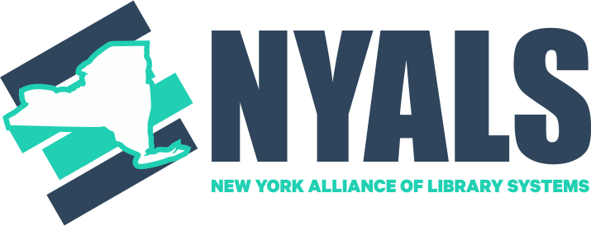

NYALS Advocacy Plan 2025-2027

Final Plan December 2024

**Intended Audience:** New York State Library Systems Directors

**Purpose of the plan:** To develop more informed, robust, and consistent advocacy efforts for NYS libraries from users/patrons & other community members, partner organizations, educational institutions, and library staff.

This plan, intended to be a living document, provides guidance for the two-year period starting in January 2025 and running through December 2026. Its first-year focus is on planning and building systems, while its second-year focus is implementation. Changes may be made on this plan through the NYALS Advocacy Plan Subgroup. This plan is designed to coordinate with and complement NYLA’s advocacy work.

**Implementation:** It is recommended that a separate ad-hoc committee of 3-4 members is formed to oversee and execute each Initiative of the Advocacy Plan, and that each system type is represented.

**Timeline:** For each initiative, Year 1 will focus on the foundational and preparatory work. Year 2 will focus on implementation and execution. Following Year 2, we will evaluate and assess our progress to determine next steps and future plans. The finer details of this timeline will need to be aligned with the NYLA legislative calendar, and in concert with other initiatives.

**Goal:** Increase user/patron and community member political engagement on behalf of all types of NYS libraries; strengthen our overall legislative advocacy apparatus.

# Initiative 1: Marketing and public relations campaign

1. Ad-Hoc Committee will be appointed and will develop expectations for a PR/marketing campaign such as deliverables, scope, and budget.
2. The appointed Ad-Hoc Committee will determine the potential means for NYALS to implement such a campaign, including exploration of the (estimated) cost of hiring a firm or consultants.
3. The appointed Ad-Hoc Committee will present options to the NYALS membership, to determine preliminary feedback and general agreement on strategy.
4. If there is interest in hiring a firm/consultants, the NYALS Steering Committee will solicit funding or donations from systems/libraries
   1. Develop a budget
   2. Develop RFP to solicit bids based on this budget
   3. Hire a firm/consultant that best provides a public relations and marketing campaign according to our requirements and budget
5. If there is no interest in hiring a firm or consultants, the Ad-Hoc Committee will develop an alternate plan with member volunteers to create tasks, responsibilities, and a timeline.

**Impact:** Users/patrons actively advocate for libraries in their communities and with their elected officials

**Measurables** (to be finalized by committee)**:**

* Measure engagement metrics based on a call to action. Success would be over 1,000 non-librarians participating in calls to action
* Engagement-based, e.g., XX advocates signed up to receive advocacy messaging
* Time-based, e.g., pre-engagement/post-engagement.
* Others, based on firm/consultant recommendations, research, etc.

# Initiative 2: Engage other organizations in a broader coalition in support of libraries & library funding

1. Appoint an Ad-Hoc Committee to create materials and one-pagers to provide systems for outreach with local organizations and adjacent groups within larger organizations (e.g. school superintendents)
2. Systems identify and contact local organizations with shared interests (NYLA has working relationships with statewide organizations that can serve as a starting point)
3. Systems (along with their member libraries, as appropriate) meet with representatives from identified organizations to establish shared goals and strategies for advancing them. We will focus on building fully reciprocal relationships where all partners bring something to the table.
4. Leverage these relationships for our broader legislative advocacy efforts, while offering reciprocal support for the partnering organizations' important advocacy efforts. Or, for certain contexts such as schools, get involved with partnering groups/organizations programs and initiatives, e.g., for the PTO.
5. Create a database with contact information for potential partner organizations

**Impact:** Libraries are visible leaders within a broader coalition of public benefit organizations. Partner organizations understand their shared interests with local libraries/systems and are advocating for them and with them in varied contexts.

**Measurables:**

* Assess the quality and quantity of relationships that are built.
* Meet with x number of new organizations at the local level.
* Assess the number of actions taken by partner organizations on behalf of libraries and systems.

# Initiative 3: Building a broader base of local library champions

1. An appointed Ad-hoc committee, including NYLA’s Director of Government Relations & Advocacy, creates a “Developing Advocates” training framework for Systems to personalize and provide to library personnel. This committee would also create a toolkit with suggestions for how to form and grow local advocacy support groups.
2. With NYALS/NYLA support, Systems hold local advocacy professional development sessions based on the Developing Advocates framework, with a special focus on new library advocates.
3. Create or work with an existing advocacy support group for libraries (e.g. legislative committees, groups of regular participants in advocacy work) with local library leaders. This may include library workers, trustees, and Friends groups.
4. In the future, the content could be adapted for use with patrons/users, parents, and other outside advocates.

**Impact:** New library personnel advocates participate in legislative events with confidence

**Measurables:**

* X new advocates have completed the Developing Advocates program.
* Survey participants in Developing Advocates program before and after to assess the effectiveness of the framework.
* X new advocates participate in legislative events.